- Systematic Prompt Analysis: You can now look at a prompt, identify its different parts (Role, Task, Context, Examples, Output Format), and pinpoint areas that need improvement.
- Iterative Prompt Development: You've practiced the core technique of making targeted changes, testing, and building upon your prompts to steadily enhance the AI's output. This includes:
  - Assigning Roles for specialized behavior.
  - Enriching Context to give the AI the knowledge and rules it needs.
  - Clarifying Tasks to remove doubt about the AI's objective.
  - Controlling Output Formats for structured and useful information.
  - Guiding with Examples (Few-Shot Prompting) to demonstrate desired responses.
- Troubleshooting AI Outputs: By understanding prompt components, you're better equipped to figure out why an AI might not be giving you the response you want and how to fix it by adjusting the prompt.

While Large Language Models (LLMs) are popular, their limitations appear in complex, multi-stage operations, especially those needing access to data not in their training set, like a weather forecast. This is where AI Agents come in. An agent uses an LLM as its "brain" to reason, plan, and act in an environment, often using external tools. We'll develop a multi-step prompt chaining workflow with intermediate validation.
Recall the common components of an AI Agent:
- Large Language Model (LLM): The "brain" for understanding, reasoning, acting.
- Tools: External functions, APIs for interaction and enhanced capabilities.
- Instructions: Guidelines (system prompts) defining behavior and goals.
- Memory: Short-term (context) & Long-term (history) for learning and consistency.
- Runtime/Orchestration Layer: Manages execution flow, tool usage, observation processing.
To achieve complex goals, agents break tasks down and execute them step-by-step, assessing progress. Let's explore a technique to accomplish this called: Prompt Chaining.

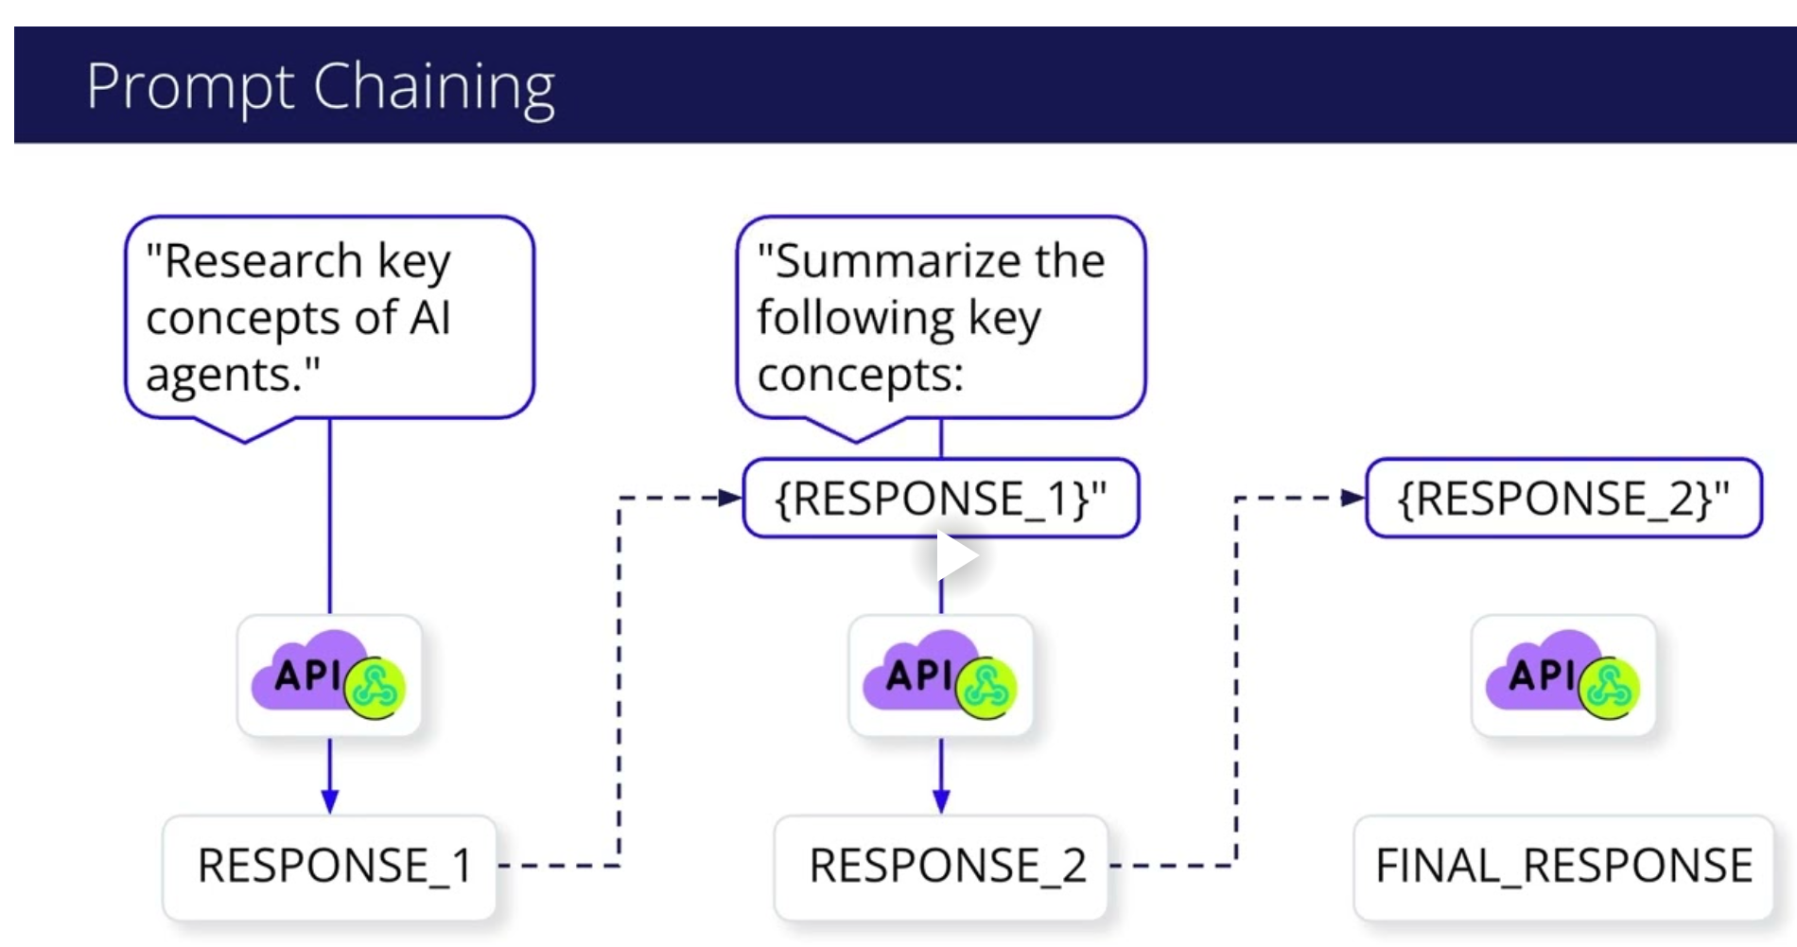
Understanding Prompt Chains
Congratulations on completing Chaining Prompts for Agentic Reasoning! You've dedicated effort to understanding how to structure more complex AI interactions, which is a foundational skill for building capable agents.
You have acquired key foundational knowledge in this area:
- Task Decomposition: You understand why complex problems should be broken down into a sequence of smaller, more focused sub-tasks for an LLM to handle effectively.
- Prompt Chaining: Prompt chaining is the technique where the output of one AI instruction programmatically becomes the input for the next, creating a processing pipeline.
- Output Validation: You know the critical role of "gate checks" for validating the output of each step in a chain to ensure reliability and prevent errors from moving down the line.
- Stage-Specific Prompting: You can recognize the importance of using distinct, specialized prompts for each part of a larger task to improve the accuracy of the AI's performance at each step.
This is the foundation you need for implementing a prompt chains. Great work!
\

